Nepal College of Information Technology
Assessment
Fall 2010
Program: ELX/CE Time: 3 hrs
Semester: Fall (III) FM: 100
Subject: Electronic Devices PM: 50
Candidates are required to give their answers in their own words as far as practicable.
The figures in the margin indicate full marks.
The figures in the margin indicate full marks.
Attempt all the questions:
1 a) What is piecewise linear modeling? Derive the expression for piecewise linear modeling of diode. [8]
b) What is biasing of diode? Describe different biasing method of diode in detail. [7]

2. a) Describe the V-I characteristics of zener diode in brief and differentiate between avalanche and zener breakdown. [8]
b) In the circuit given below, Vin=80-120V. Find the minimum and maximum zener current. [7]
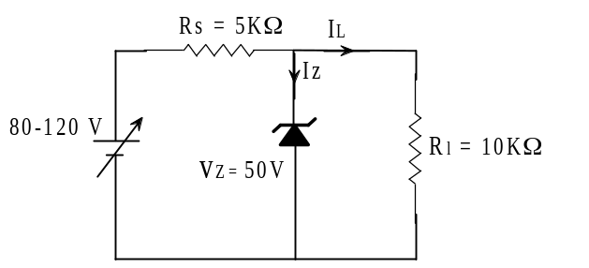

3. a) Describe the input and output characteristics of common base configuration. [8]
b) In the given circuit, operating point is chosen as Ic = 2mA, Vce =3V. If Rc = 2.2KΩ, Vcc = 9V and β = 50, determine R₁, R₂, R_{E.} Take V_{BE} = 0.3V and I₁ = 10I _{B}. [7]
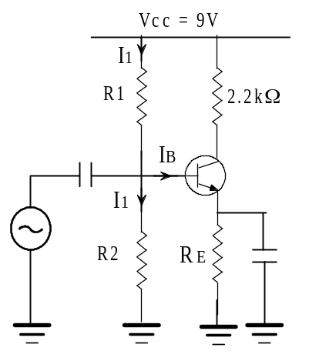

4. a) For the given amplifier circuit, find: [8]
i) Input resistance directly looking into base.
ii) Input resistance of the stage
iii) Voltage gain
iv) Overall voltage gain
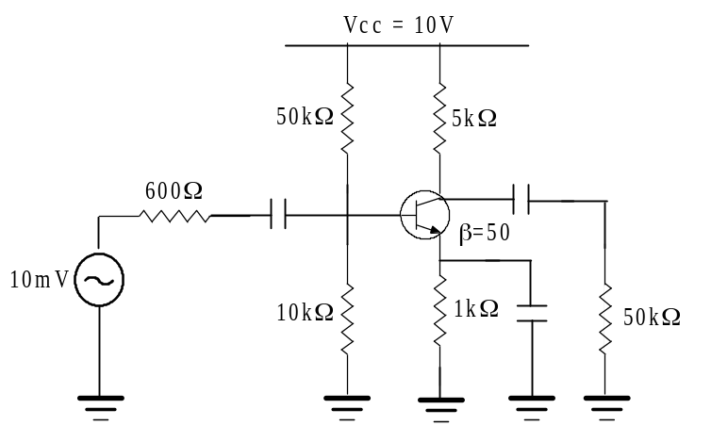
b) What is ripple factor? Calculate the ripple factor for half wave and full wave rectifier. [7]

5. a) Differentiate between BJT and FET. Describe the transfer characteristics of JFET. [8]
b) In an n-channel JFET biased by potential divider method, it is desired to set the operating point at I_{D} = 2.5mA and V_{DS} = 8V. If V_{DD} = 30V, R₁ = 1MΩ and R₂ = 500KΩ, find the value of R_{S}. The parameters of JFET are I_{DSS} = 10mA and V_{P} = -5V. [7]
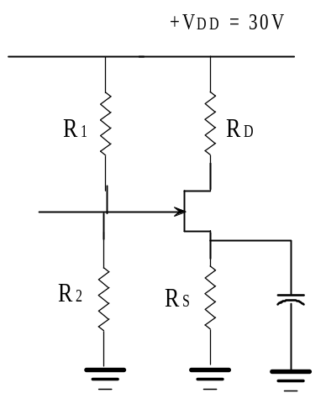

6. a) Sketch the output waveform for the following circuit. [7]
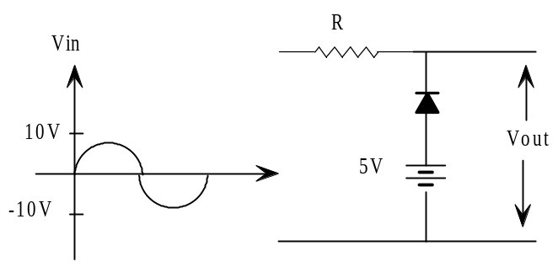
b) Sketch the output waveform for the circuit shown in figure below. It is given that discharging time constant is mush larger than the time period of input wave. [8]
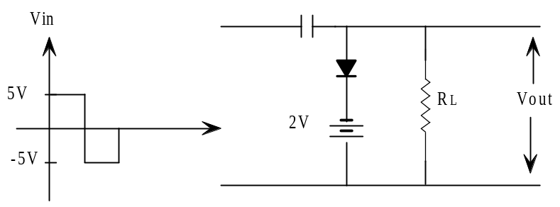

7. Write short notes on(any two) [5*2=10]
a) Transistor as an inverter
b) Thermal runaway
c) Thermal resistance.

